**AWS Task-2**

**Task Description:**

Set up a VPC with an Internet gateway, create a public subnet with 256 IP addresses, a private subnet with 256 IP addresses, make a route table connecting the Internet gateway and the subnets, and launch a Linux EC2 instance by using the above VPC and public subnet.

VPC: mytestvpc

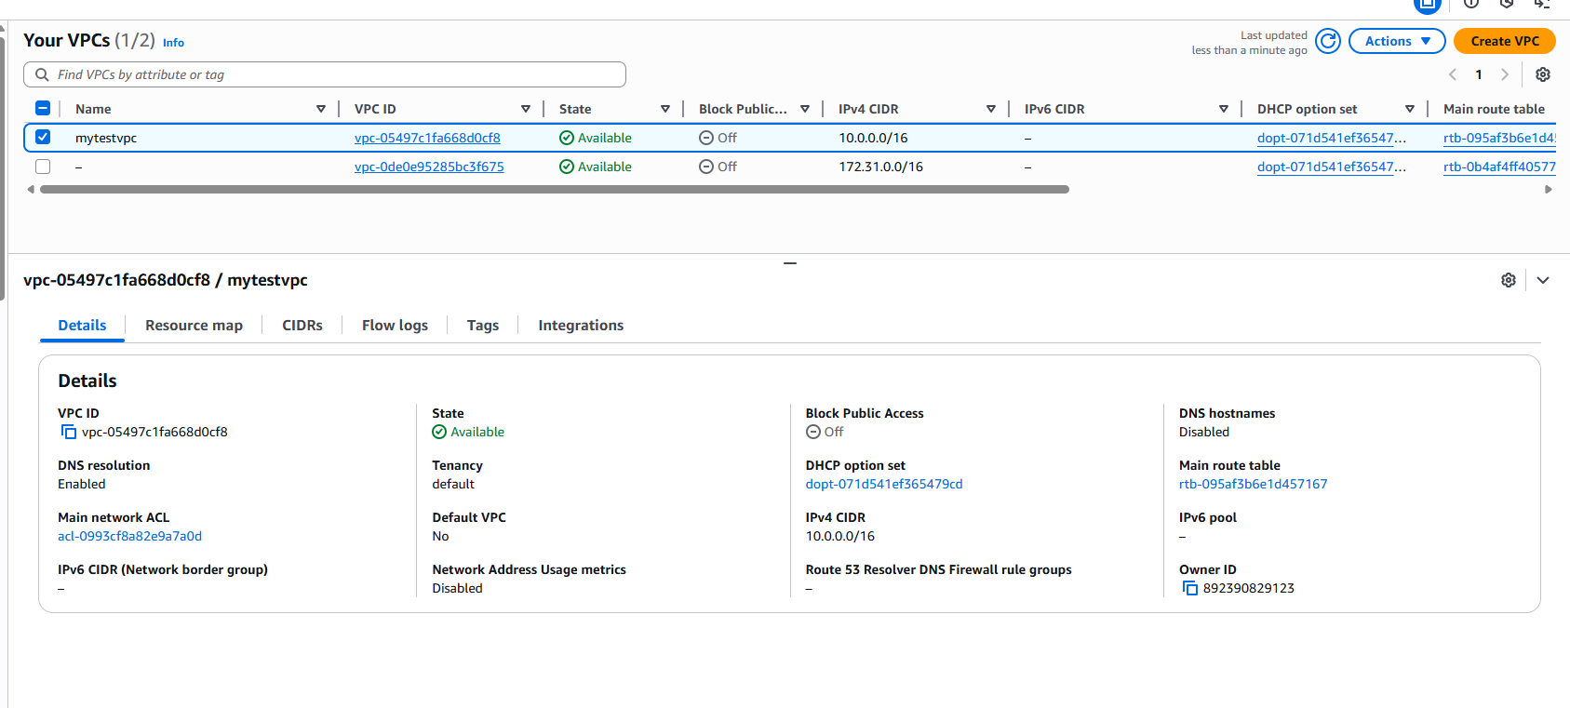

Internetgateway:

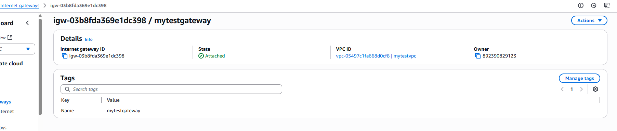

Subnets:

Mupublicsubnet:

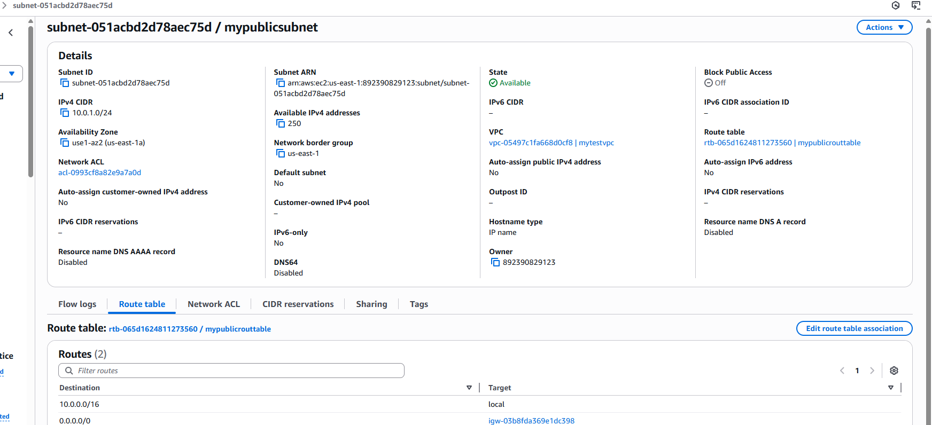

Myprivatesubnet:

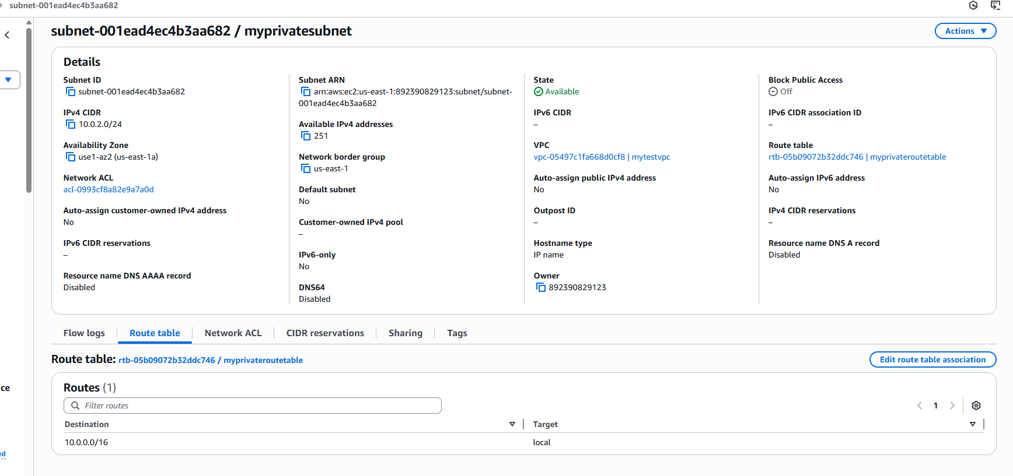

Routetable associated with the internet gateway and subnets:

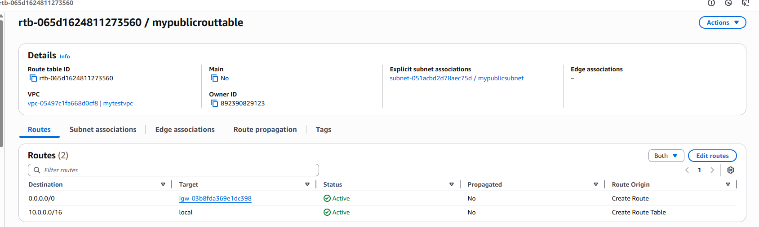

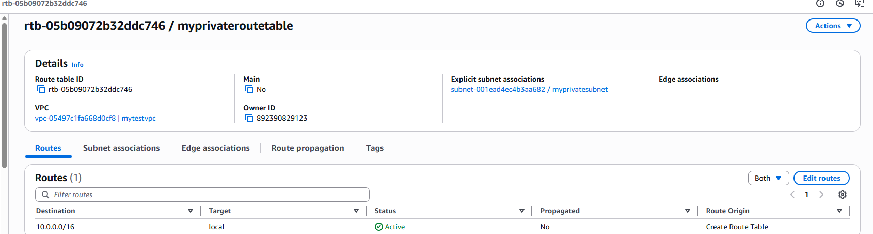

EC2 Instance launched by the created vpc and subnets:

